1. **See Appendix**
2. **I implemented both versions :)**
3. **Algorithm discussion**
   1. **Overall**
      * Time
        + There’s nothing in the methods that call dijkstrasArray() and dijkstrasHeap() that has a greater time complexity than either of them. Therefore the time complexity will depend on which method is chosen. This would give us a O(v2) since the worst option is the array implementation.
      * Space
        + Space complexity is always the same, just O(v). This is because the only space we have taken up is the network which contains an array of nodes. Each node has a constant number of elements, so space complexity is just O(n)
   2. **Array**
      * Time
        + Time complexity of the array implementation is O(v2) where v is the number of total points. This is because in the worst case scenario, you have to add each point to the priority queue, and take each point off. This would result in performing the deleteMin() operation v times, and deleteMin() takes v time. Thus, O(v2)
      * Space
        + Space complexity is always the same, just O(v). This is because the only space we have taken up is the network which contains an array of nodes. Each node has a constant number of elements, so space complexity is just O(n)
   3. **Heap**
      * Time
        + Time complexity is O(vlogv), where v is the number of total points. This is because in the worst case scenario, we add each element to the priority queue and have to take it off with deleteMin(). WIth the heap implementation, deleteMin() time is only O(logv), because we use a method to keep the heap sorted and the min node at the top at all times. Thus, we would call a O(logv) method v times, and therefore O(vlogv)
      * Space
        + Space complexity is always the same, just O(v). This is because the only space we have taken up is the network which contains an array of nodes. Each node has a constant number of elements, so space complexity is just O(n)
4. Screenshots

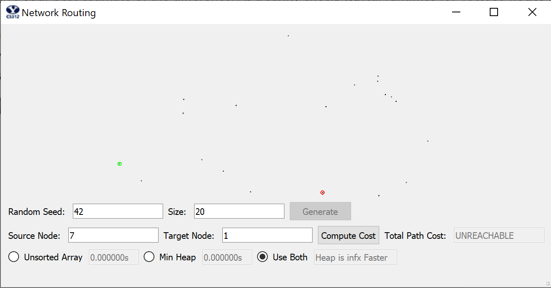

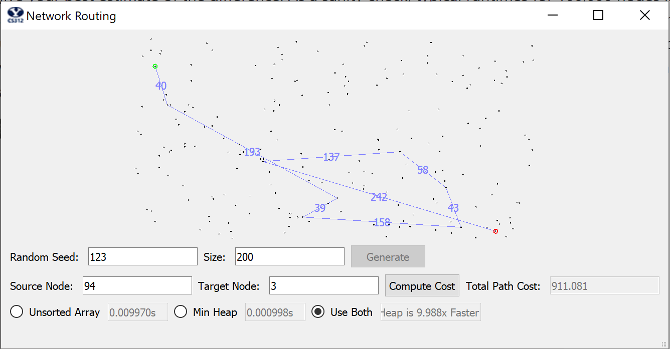

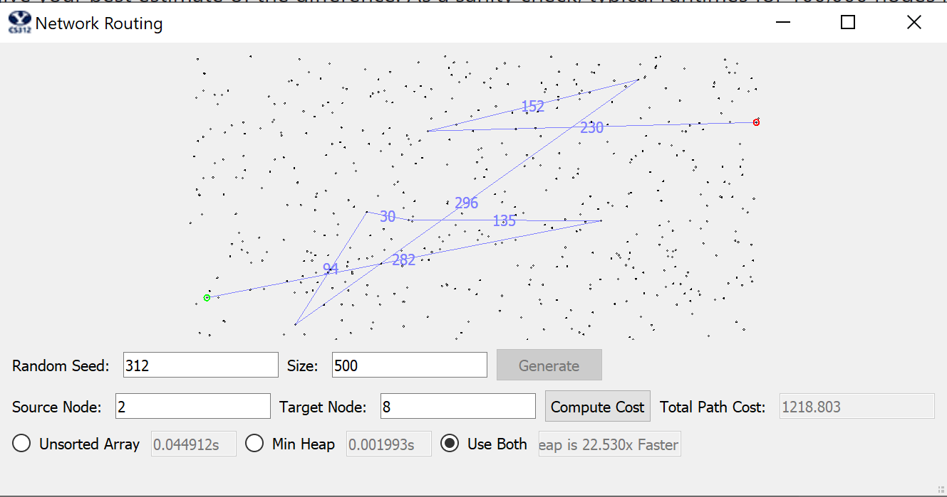

1. **Analysis**
   1. **Graph**
      * 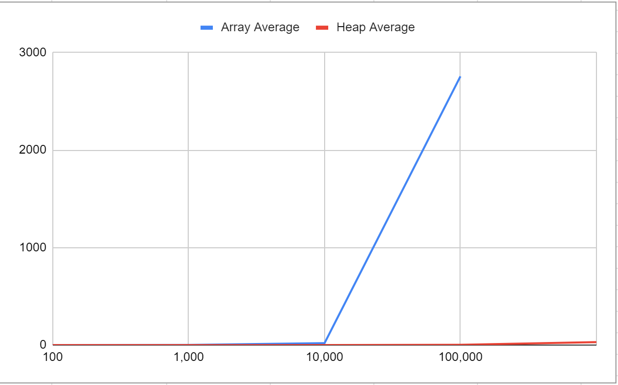
   2. **Table**
      * 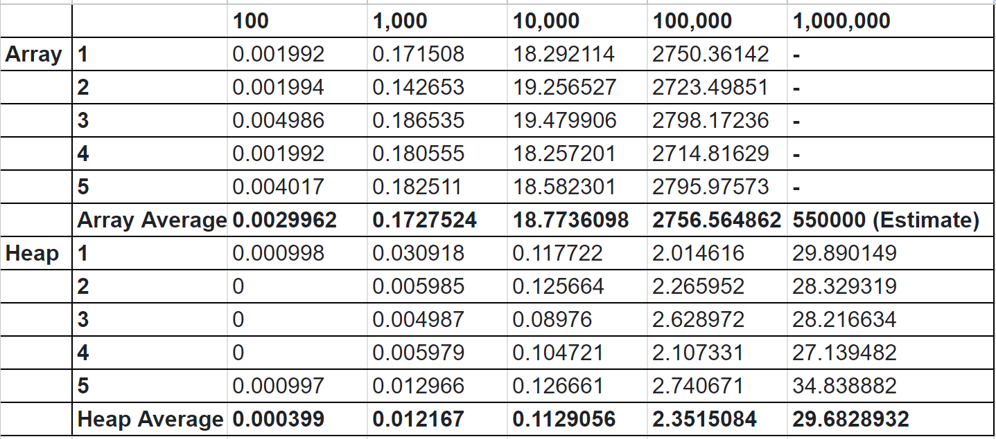
   3. **Discussion**
      * The heap has run very predictably and very quickly, increasing by logarithmic amount each time. This seems very in line with what you would expect from the heap implementation. The array on the other hand is not what I expected. It’s possible this is the effect of non-theoretical uses of time. For example, because the time complexity is v2, it may be that I’m doing a v2 operation a constant number of times, but if that constant is even 3 or so, it could have disastrous effects on real life results of this operation when using large numbers. This is my best explanation for why the numbers turned out the way they did.

**Appendix**

***#!/usr/bin/python3***

**import math**

**import random**

**from CS312Graph import \***

**import time**

**class NetworkRoutingSolver:**

**shortestPath = [[]]**

**def __init__( self):**

**pass**

**def initializeNetwork( self, network ):**

**assert( type(network) == CS312Graph )**

**self.network = network**

**def getShortestPath( self, destIndex ):**

**self.dest = destIndex**

**def findDestinationNodeIndex():**

**for index in range(len(self.shortestPath)):**

**if self.shortestPath[index][0] == destIndex:**

**return index**

**path_edges = []**

**total_cost = 0**

**currentIndex = findDestinationNodeIndex()**

**if currentIndex == None:**

**return {'cost': math.inf, 'path': []}**

**backPointer = self.shortestPath[currentIndex][1]**

**while True:**

**if backPointer == None:**

**break**

**while self.shortestPath[currentIndex][1] != backPointer:**

**currentIndex -= 1**

**nodesIndex = self.shortestPath[currentIndex][0]**

**if self.network.nodes[backPointer].neighbors[0].dest.node_id == nodesIndex:**

**edge = self.network.nodes[backPointer].neighbors[0]**

**elif self.network.nodes[backPointer].neighbors[1].dest.node_id == nodesIndex:**

**edge = self.network.nodes[backPointer].neighbors[1]**

**else:**

**edge = self.network.nodes[backPointer].neighbors[2]**

**path_edges.append((edge.src.loc, edge.dest.loc, '{:.0f}'.format(edge.length)))**

**total_cost += edge.length**

**while self.shortestPath[currentIndex][0] != backPointer:**

**currentIndex -= 1**

**backPointer = self.shortestPath[currentIndex][1]**

**return {'cost': total_cost, 'path': path_edges}**

**def computeShortestPaths( self, srcIndex, use_heap ):**

**self.source = srcIndex**

**t1 = time.time()**

**if not use_heap:**

**self.shortestPath = self.dijkstrasArray(srcIndex)**

**else:**

**self.shortestPath = self.dijkstrasHeap(srcIndex)**

**t2 = time.time()**

**return (t2-t1)**

**def dijkstrasArray(self, srcIndex):**

**def makeQueue(srcIndex):**

**pQueue = [[UNREACHABLE, None] for _ in range(len(self.network.nodes))]**

**pQueue[srcIndex][0] = 0**

**return pQueue**

**def decreaseKey(pQueue, index, distance, lastNode):**

**pQueue[index] = [distance, lastNode]**

**def deleteMin(pQueue):**

**minValue = UNREACHABLE**

**minIndex = 0**

**for index in range(len(pQueue)):**

**if ((minValue == UNREACHABLE or pQueue[index][0] < minValue)**

**and pQueue[index][0] != UNREACHABLE**

**and pQueue[index][0] != VISITED):**

**minIndex = index**

**minValue = pQueue[index][0]**

**pQueue[minIndex][0] = VISITED**

**return minIndex, minValue**

**VISITED = -2**

**UNREACHABLE = -1**

**shortestPath = []**

**pQueue = makeQueue(srcIndex)**

**while True:**

**minIndex, minValue = deleteMin(pQueue)**

**if minValue == UNREACHABLE:**

**break**

**shortestPath.append([minIndex, pQueue[minIndex][1]])**

**if len(shortestPath) == len(self.network.nodes):**

**break**

**neighbors = self.network.nodes[minIndex].neighbors**

**for index in range(3):**

**neighborID = neighbors[index].dest.node_id**

**neighborDistance = neighbors[index].length**

**if (pQueue[neighborID][0] != VISITED**

**and ((pQueue[neighborID][0] == UNREACHABLE) or (neighborDistance + minValue) < pQueue[neighborID][0])): *# Replaced index with neighborID in (neighborDistance + minValue) < pQueue[neighborID][0]))***

**decreaseKey(pQueue, neighborID, neighborDistance + minValue, minIndex)**

**return shortestPath**

**def dijkstrasHeap(self, srcIndex):**

**def makeQueueAndPointerArray(srcIndex):**

**pq = [[None, UNREACHABLE, None] for _ in range(len(self.network.nodes))] *#NodeNumber, currentCost, backpointer***

**pointerArray = [UNREACHABLE for _ in range(len(self.network.nodes) + 1)]**

**pq[0] = [srcIndex, 0, None]**

**pointerArray[srcIndex] = 0**

**pointerArray[len(pointerArray) - 1] = 1 *# Last index keeps track of where the next Null spot is***

**return pq, pointerArray**

**def insert(value: [int, int, int | None]):**

**nextNullSpot = pointerArray[len(pointerArray) - 1]**

**pq[nextNullSpot] = value**

**pointerArray[value[0]] = nextNullSpot**

**pointerArray[len(pointerArray) - 1] += 1**

**bubbleUp(nextNullSpot)**

**def deleteMin():**

**lowestItemIndex = pointerArray[len(pointerArray) - 1] - 1**

**smallestNode = pq[0]**

**pointerArray[smallestNode[0]] = VISITED**

**pq[0] = pq[lowestItemIndex]**

**if lowestItemIndex != 0:**

**pointerArray[pq[0][0]] = 0**

**pq[lowestItemIndex] = [None, -1, None]**

**pointerArray[len(pointerArray) - 1] = lowestItemIndex**

**siftDown()**

**return smallestNode**

**def decreaseKey(newNodeValue):**

**pqIndex = pointerArray[newNodeValue[0]]**

**pq[pqIndex] = newNodeValue**

**bubbleUp(pqIndex)**

**def siftDown():**

**parentIndex = 0**

**while True:**

**child1Index = (2 * parentIndex) + 1**

**child2Index = (2 * parentIndex) + 2**

**outOfBoundsIndex = pointerArray[len(pointerArray) - 1]**

***# Both children out of bounds***

**if child1Index >= outOfBoundsIndex and child2Index >= outOfBoundsIndex:**

**break**

***# child2 out of bounds***

**elif child2Index >= outOfBoundsIndex:**

**if pq[parentIndex][1] < pq[child1Index][1]:**

**break**

**else:**

**swapIndex = child1Index**

***# Neither child out of bounds***

**else:**

**if pq[parentIndex][1] < pq[child1Index][1] and pq[parentIndex][1] < pq[child2Index][1]:**

**break**

**elif pq[child1Index][1] < pq[child2Index][1]:**

**swapIndex = child1Index**

**else:**

**swapIndex = child2Index**

**parent = pq[parentIndex]**

**child = pq[swapIndex]**

**pq[parentIndex] = child**

**pq[swapIndex] = parent**

**pointerArray[pq[parentIndex][0]] = parentIndex**

**pointerArray[pq[swapIndex][0]] = swapIndex**

**parentIndex = swapIndex**

**def bubbleUp(newNodeLocation):**

**currentParentIndex = math.floor((newNodeLocation - 1) / 2)**

**while pq[newNodeLocation][1] < pq[currentParentIndex][1]:**

**childValue = pq[newNodeLocation]**

**parentValue = pq[currentParentIndex]**

**pq[newNodeLocation] = parentValue**

**pq[currentParentIndex] = childValue**

**pointerArray[parentValue[0]] = newNodeLocation**

**pointerArray[childValue[0]] = currentParentIndex**

**newNodeLocation = currentParentIndex**

**currentParentIndex = math.floor(newNodeLocation / 2)**

**UNREACHABLE = -1**

**VISITED = -2**

**pq, pointerArray = makeQueueAndPointerArray(srcIndex)**

**shortestPath = []**

**while pointerArray[len(pointerArray) - 1] != 0:**

**nextNode = deleteMin()**

**shortestPath.append([nextNode[0], nextNode[2]])**

**neighbors = self.network.nodes[nextNode[0]].neighbors**

**for index in range(3):**

**neighborID = neighbors[index].dest.node_id**

**neighborDistance = neighbors[index].length**

**if pointerArray[neighborID] == VISITED:**

**continue**

**elif pointerArray[neighborID] == UNREACHABLE:**

**insert([neighborID, neighborDistance + nextNode[1], nextNode[0]])**

**elif (neighborDistance + nextNode[1]) < pq[pointerArray[neighborID]][1]:**

**decreaseKey([neighborID, neighborDistance + nextNode[1], nextNode[0]])**

**return shortestPath**